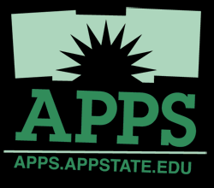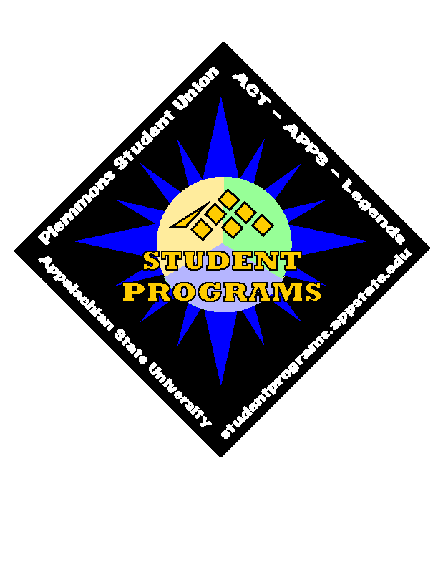
Appalachian State University
Position Announcement
Associate Director for Programming,
Department of Student Programs and the
Plemmons Student Union

Appalachian State University is seeking a dynamic, creative, energetic, organized professional to join a great team in working with a large group of committed, intelligent and talented student leaders to plan, advertise and produce entertainment programs at one of the nation’s premier comprehensive universities. The position reports to the Director of Student Programs and the Plemmons Student Union and affords the unique opportunity of working with experienced professionals in a team approach to create more that 200 live programs, special events and films each year. The Department of Student Programs has a 25 year history of producing outstanding student leaders and dynamic, diverse programs in some of the best facilities anywhere; including the award winning Plemmons Student Union, the 8500 seat Holmes Convocation Center, the 1700 seat Farthing Auditorium and the 1000 person capacity “Legends”, a student run night club hosting 40-60 live bands, comedians, and DJ dances each year. The successful candidate advises the Appalachian Popular Programming Society (A.P.P.S.) with 200 members in seven programming councils. As such, APPS is one of the largest, best run, most successful student programming organizations on any campus in America. The position description and more information about the Department of Student Programs, A.P.P.S., Legends and Appalachian State University is available at www.studentprograms.appstate.edu. Appalachian has 16,500 students and is located in beautiful Boone, N.C., a vibrant college town of about 15,000 people situated in the Blue Ridge Mountains of North Carolina. www.exploreboonearea.com

Job Description:

The Associate Director of Student Programs leads the departmental team in the planning and production of student produced diverse entertainment programs designed to enhance the co-curricular environment at ASU. The Associate Director will advise the University’s Program Board (APPS) and one of the seven student run APPS program councils. The Associate Director will assist in policy development for two university programming facilities and the programs presented in each. The Associate Director oversees programming budget coordination for the Department of Student Programs. The Associate Director supervises two Grad Assistants, graduate interns and student leaders and coordinates APPS training programs. The Associate Director will oversee departmental marketing and promotions, and will supervise and train a team of student graphic designers, including website management for several departmental websites. Occasional evening and weekend work is expected as part of a flexible work schedule.

Page 2
Associate Director for Programming, Department of Student Programs
and the Plemmons Student Union

Qualifications: Minimum 3 years full-time experience in planning entertainment programs and advising campus program board committees, or closely related experience. Five or more years of increasing responsibilities in a University Student Development Department preferred. Successful candidate must be team oriented, organized, a skillful and dynamic trainer, effective contract negotiator, skilled in graphic design, marketing, website development and possess advanced computing skills. Masters Degree in College Student Development or related field required, along with a commitment to the growth and development of college students.
Compensation: Minimum starting salary $45,000; plus North Carolina State benefits.

To apply: Send current resume, letter of application and names and phone numbers of 3-5 references who know you well, to:

studentunion@appstate.edu
Attention: Brad Vest, Search Chair
*Only electronic applications will be accepted

Deadline to apply: Applications are being received until position is filled. Review of applications will begin in mid October.

Individuals with disabilities desiring accommodations in the application process should contact Brad Vest, Search Chairperson.

Proper documentation of identity and employability will be required before the hiring process can be finalized.

University policy requires a criminal background check for all applicants invited to campus for an interview.

Appalachian State University
A member institution of The University of North Carolina System
An Affirmative Action/Equal Opportunity Employer

Revised 9/24/2010 2:30pm
Complete Job Description
Associate Director for Programming
Department of Student Programs
Appalachian State University
www.studentprograms.appstate.edu
www.apps.appstate.edu

Job Title
Associate Director for Programming, Department of Student Programs and the Plemmons Student Union

General Job Description:

The Associate Director of Student Programs shares responsibility for the development and implementation of entertainment programs designed to enhance the co-curricular and social environment at ASU. The Associate Director will advise the University’s Programming Board Executive Council (Appalachian Popular Programming Society), and up to two student run program councils of APPS. This individual will work with the director in policy development for two university programming facilities and the programs presented in each. Responsibilities include training and oversight of a team of student graphic designers and website managers. Homecoming coordination and certain campus festivals are part of the position responsibilities. The Associate Director will share programming budgetary coordination for the Department of Student Programs. The Associate Director will informally teach student development and program planning principles to student leaders, graduate assistants, and interns. The Assoc. Director coordinates APPS summer leadership retreat and ongoing training programs. The opportunity exists to teach a Leadership Development course each year. This staff member will supervise and coordinate the educational efforts of two Graduate Assistants. The Associate Director of Student Programs reports directly to the Director of Student Programs. Occasional evening and weekend work expected as part of a flexible work schedule.

Administrative/Management/Supervisory Responsibilities
- Assist in policy formulation for the Student Union and Legends Campus Nightclub/Social Center. Provide occasional support for Legends operational supervision.
- Consult with student leaders in the budget preparations for all programming budget accounts under the jurisdiction of the Division of Student Programs.
- Contribute to the development of policies and student job descriptions within the Department of Student Programs.
- Supervise/coordinate selected programs and festivals sponsored by the Department of Student Programs.
- Assist the director in the overall management of the Department of Student Programs.
- Chair the university’s homecoming coordination and planning effort.
- Serve on university committees as assigned.
- Perform other duties as assigned by the Director of Student Programs.

Instruction/Leadership Training and Development
- Supervise practicum, internship, and graduate student assistants working in Student Programs including holding periodic meetings, defining duties, instructing on office policies and procedures, and developing and monitoring projects.
- Recruit new internship and practicum students, and conduct regular evaluations of graduate students working in the office.
- Teach up to one leadership development course a year, if desired.
- Conduct seminars and workshops for student leaders on topics related to successful programming and organizational leadership.
- Plan the logistics for the annual APPS leadership retreat including booking the site, corresponding with the APPS leaders, planning meals, and organizing/leading the retreat Educational Sessions.

Communication
- Maintain the Homecoming/Jazzfest/Accapella show website: www.specialevents.appstate.edu
- Compile and edit an E-newsletter about programming opportunities.
- Co-produce the Homecoming Handbook.

Marketing/Advertising Outreach
- Assist in the development of marketing plans for the programs and services offered by the Department of Student Programs.
- Recruit, train and supervise a team of student graphic designers and website managers.
- Teach APPS leaders and GA’s strategies for effective marketing and advertising.
- Serve as Learning Partner for ACT Alternative Spring Break, if desired.

Collaboration
- Assist in the overall development of a comprehensive cultural, social, and co-curricular program for the ASU community.
- Chair the Homecoming Committee including recruiting new members, compiling the activities of various departments and student organizations, coordinating the publicity of the campus-wide homecoming activities and directing certain homecoming events.
- Chair the Accapellagedon planning committee, including contacting and booking acts, monitoring the programming budget and developing a marketing plan.
- Attend selected events including APPS Special Events, Council for Cultural awareness events, Appalachian Heritage Festival events, and events that require office-wide support such as large concerts or co-sponsored campus-wide events.
- Establish positive working relationships with faculty, staff, and students.
- Serve on the University Graduate Assistant Placement Program Committee.

Advising
- Advise the APPS Executive Council including holding weekly meetings and monitoring projects and expenditures. Meet weekly with APPS President and Executive Cabinet.
- Advise the APPS Vice Presidents (Public Relations, Communications, and Membership and Community Development).

Associate Director Job Description
Page 3

- Co-advise along with a graduate assistant, the APPS Appalachian Heritage Council including holding weekly meeting with the chairperson, and supervising the GA in contacting and booking acts, and monitoring the programming budgets.
- Co-advise, along with a graduate assistant, the APPS Council for Cultural Awareness including holding weekly meetings with the chairperson, and supervising the GA contacting and booking acts, and monitoring the programming budgets.
- Advise the Special Events Council of APPS

Assessment
- Work with the other advisors to the Appalachian Popular Programming Society to Develop, disseminate and tabulate evaluations on programs, learning outcomes services offered by Student Programs.
- Gather APPS student leadership assessment data and analyze results to determine both skill development and learning outcomes. Implement new educational initiatives resulting from data analysis.

Professional Development
- Coordinate graduate student staff development efforts of the Department of Student Programs.
- Engage in professional developments activities related to leadership development, teaching and administrative responsibilities.
- Maintain a commitment to personal growth and development.
- Role model high ethical, moral and professional behaviors.
Seek to be active professionally in either the National Association for Campus Activities, Association of College Unions International, or some other closely related professional endeavor.

